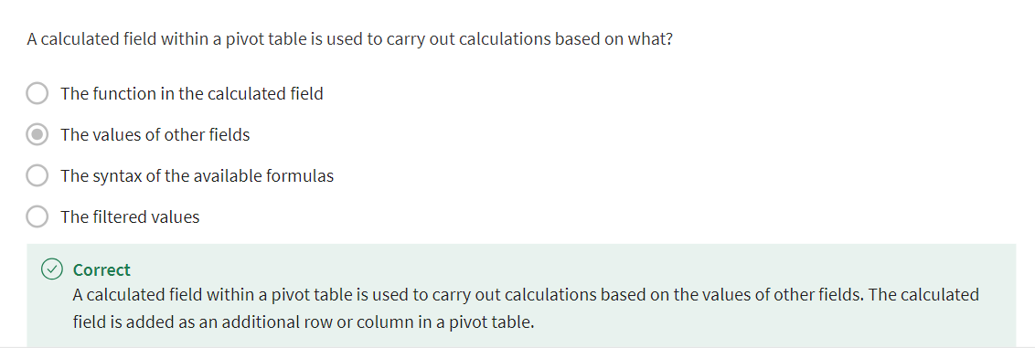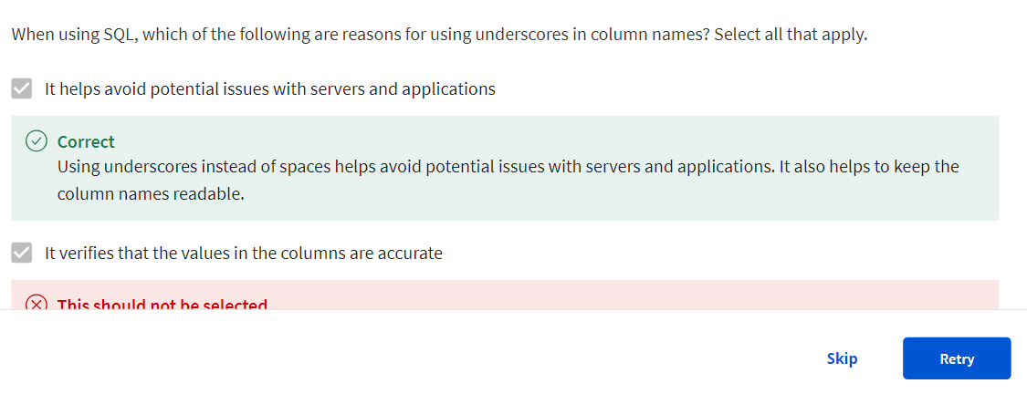
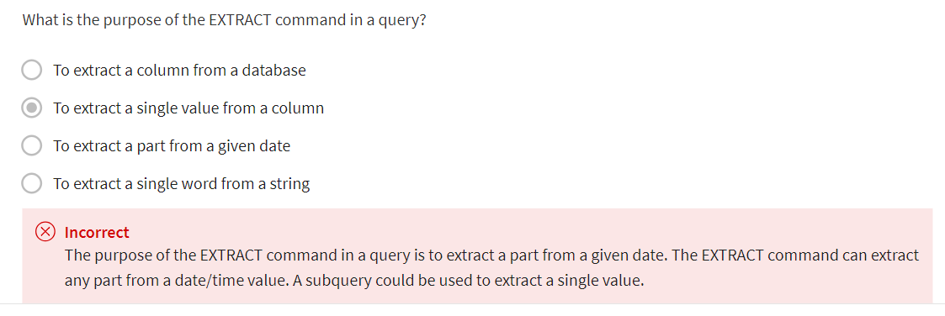

Types of data validation
This reading describes the purpose, examples, and limitations of six types of data validation. The first five are validation types associated with the data (type, range, constraint, consistency, and structure) and the sixth type focuses on the validation of application code used to accept data from user input.
As a junior data analyst, you might not perform all of these validations. But you could ask if and how the data was validated before you begin working with a dataset. Data validation helps to ensure the integrity of data. It also gives you confidence that the data you are using is clean. The following list outlines six types of data validation and the purpose of each, and includes examples and limitations.
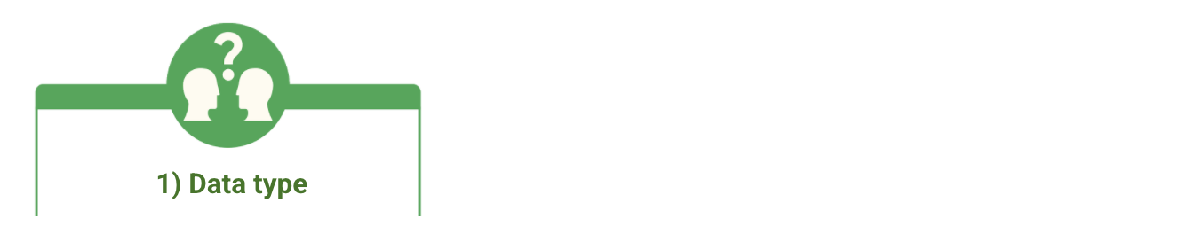
- Purpose: Check that the data matches the data type defined for a field.
- Example: Data values for school grades 1-12 must be a numeric data type.
- Limitations: The data value 13 would pass the data type validation but would be an unacceptable value. For this case, data range validation is also needed.

- Purpose: Check that the data falls within an acceptable range of values defined for the field.
- Example: Data values for school grades should be values between 1 and 12.
- Limitations: The data value 11.5 would be in the data range and would also pass as a numeric data type. But, it would be unacceptable because there aren't half grades. For this case, data constraint validation is also needed.
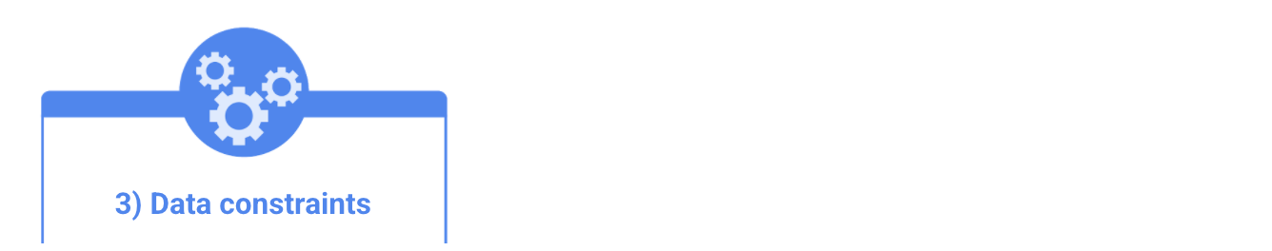
- Purpose: Check that the data meets certain conditions or criteria for a field. This includes the type of data entered as well as other attributes of the field, such as number of characters.
- Example: Content constraint: Data values for school grades 1-12 must be whole numbers.
- Limitations: The data value 13 is a whole number and would pass the content constraint validation. But, it would be unacceptable since 13 isn’t a recognized school grade. For this case, data range validation is also needed.
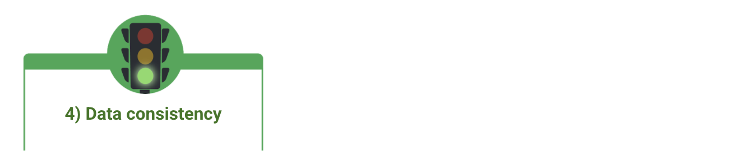
- Purpose: Check that the data makes sense in the context of other related data.
- Example: Data values for product shipping dates can’t be earlier than product production dates.
- Limitations: Data might be consistent but still incorrect or inaccurate. A shipping date could be later than a production date and still be wrong.
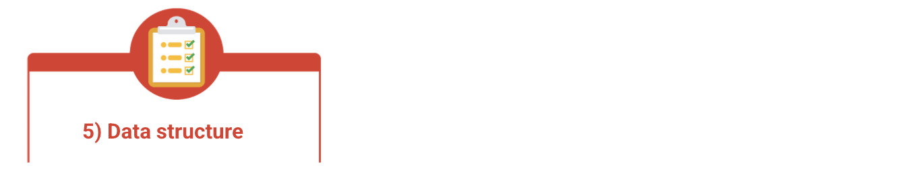
- Purpose: Check that the data follows or conforms to a set structure.
- Example: Web pages must follow a prescribed structure to be displayed properly.
- Limitations: A data structure might be correct with the data still incorrect or inaccurate. Content on a web page could be displayed properly and still contain the wrong information.
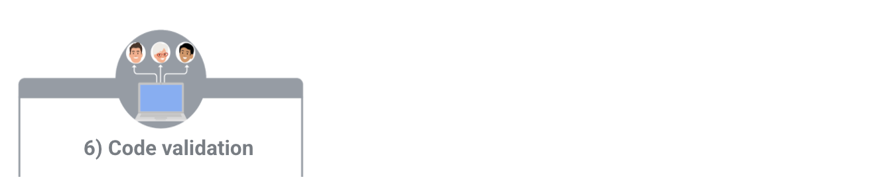
- Purpose: Check that the application code systematically performs any of the previously mentioned validations during user data input.
- Example: Common problems discovered during code validation include: more than one data type allowed, data range checking not done, or ending of text strings not well defined.
- Limitations: Code validation might not validate all possible variations with data input.
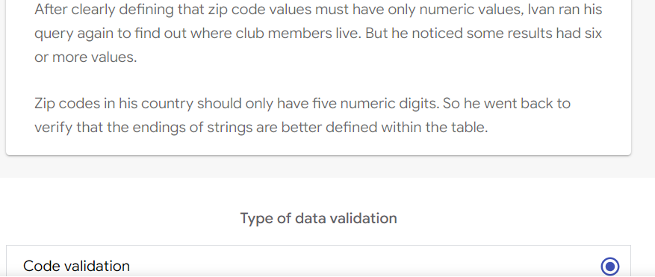
Key takeaways
Connected Sheets provides a tremendous opportunity to analyze large data sets without specialized skills like SQL. Use familiar spreadsheet skills such as pivot tables, charts, and formulas to analyze the data. For junior data analysts in particular, Connected Sheets can help them perform key tasks within BigQuery and increase their marketable skills.
Resources for more information
- Get started with BigQuery data in Google Sheets
- Insights at scale with Google Sheets
- Connected Sheets product announcement
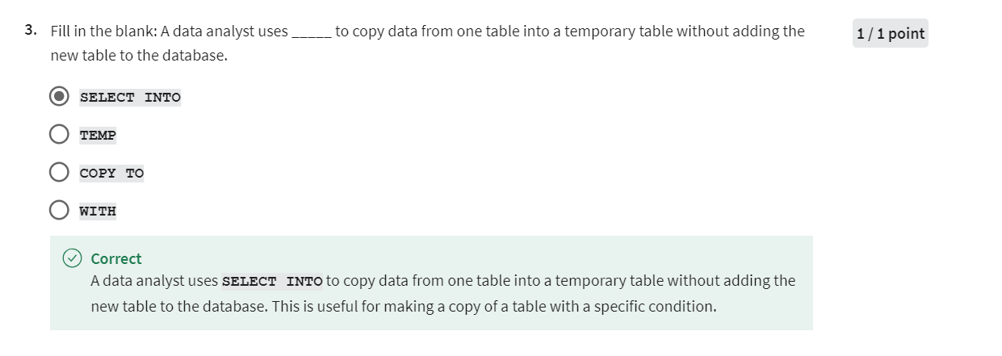

Glossary terms from module 4
Terms and definitions for Course 5, Module 4
Array: A collection of values in spreadsheet cells
Calculated field: A new field within a pivot table that carries out certain calculations based on the values of other fields
Data security: Protecting data from unauthorized access or corruption by adopting safety measures
Data validation process: The process of checking and rechecking the quality of data so that it is complete, accurate, secure and consistent
GROUP BY: A SQL clause that groups rows that have the same values from a table into summary rows
Modulo: An operator (%) that returns the remainder when one number is divided by another
Profit margin: A percentage that indicates how many cents of profit has been generated for each dollar of sale
Summary table: A table used to summarize statistical information about data
SUMPRODUCT: A function that multiplies arrays and returns the sum of those products
Temporary table: A database table that is created and exists temporarily on a database server
Underscores: Lines used to underline words and connect text characters

